# Email Relay

Go to login.microsoftonline.com. Sign in as Administrator. Click ‘Admin’ link at the top bar.

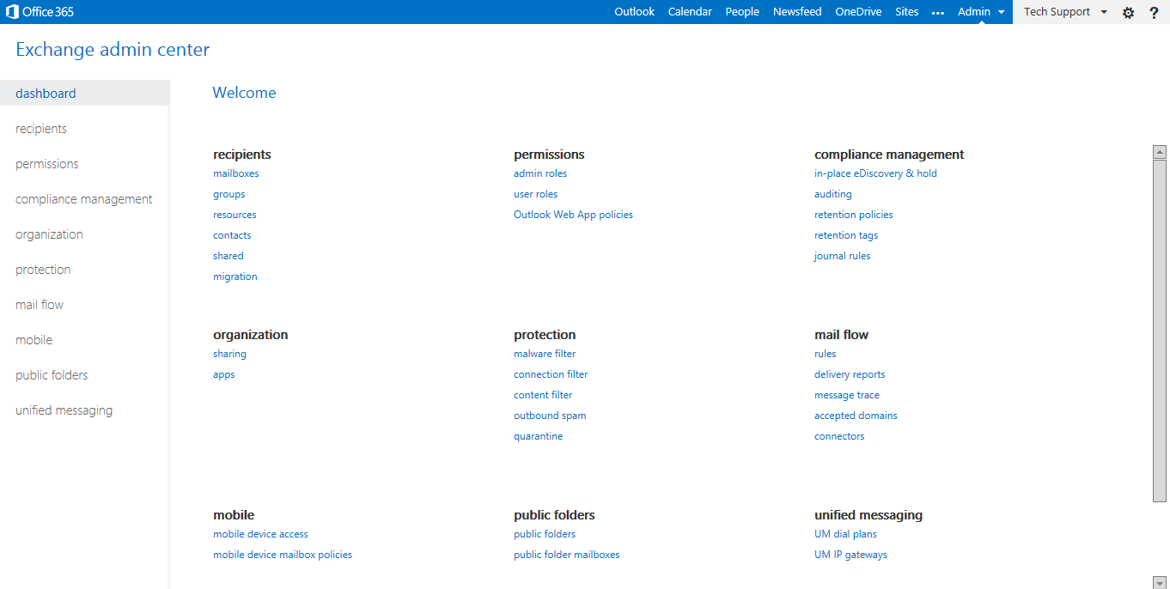

From left panel, click ‘mail flow’ link.

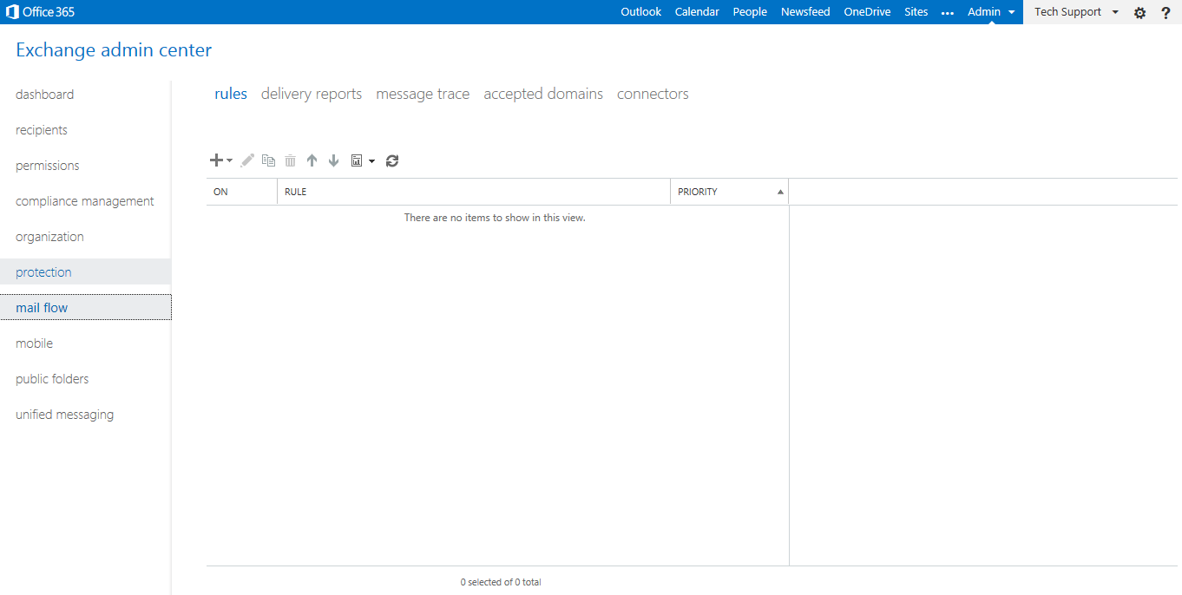

Click ‘accepted domains’ tab on the top bar.

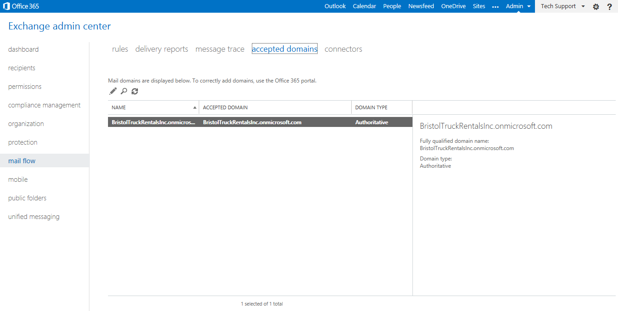

Select the company and click ‘edit’, it will open a new page as below:

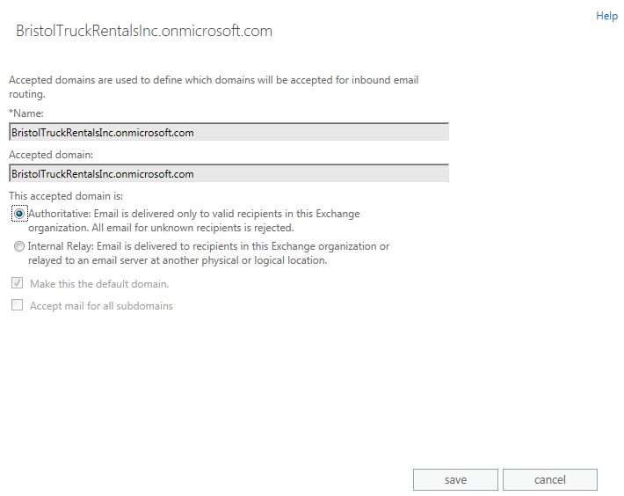

Choose second option ‘Internal Relay: Email is delivered to …’

